Selenium WebDriver Architectue

Open source tool use for browser UI automation.

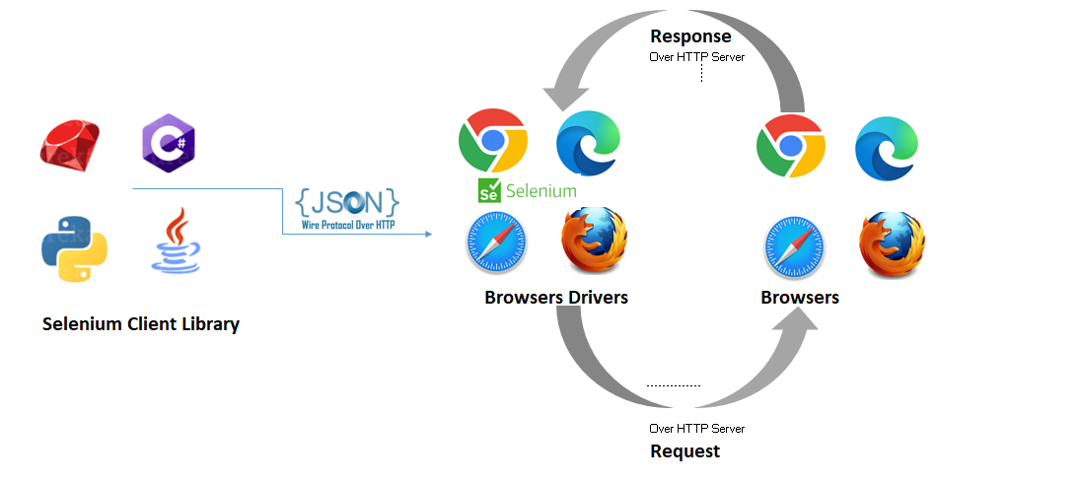`**How selenium works?**

* After you trigger the Test, complete Selenium code (Client) which we have written will be converted to Json format.
* Generated Json is sent to Browser Driver (Server) through http Protocol

Note: Each browser contains a separate browser driver

* . Browser drivers communicate with its respective browser and executes the commands by interpreting Json which It received on the browser.
* Browser Driver receives responses back from the browser and it sends Json response back to Client.

**Advantages:**

1. Open-Source and Free to Use
2. Supports Multiple Programming Languages - **Java, Python, C#, Ruby, and JavaScript.**
3. Cross-Browser Compatibility
4. Multi-Platform Support - **Windows, macOS, and Linux.**
5. **Flexibility in Test Case Design**
6. Easily integrate with testing framework (Cucumber/ TestNG)

**Disadvantages:**

1. Limited Support for Desktop and Mobile Apps.
2. Complex Setup and Configuration.
3. Limited Reporting and Debugging Features.
4. Performance Issues with Large Test Suites.
5. Handling Popups and Alerts.
6. Limited Browser-Specific Features.
7. Steep Learning Curve for Beginners.

**Starting with first selenium test**

1. Create a Java Maven project.

Project structure looks like

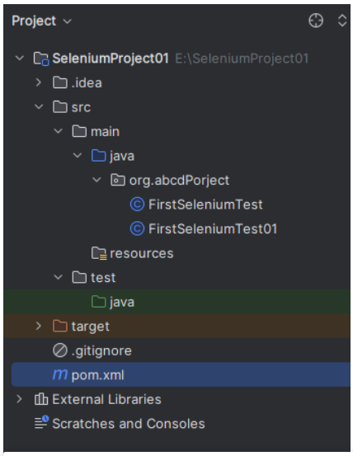

1. Add Below dependencies in pom.xml file
2. Selenium Dependency: To use selenium library

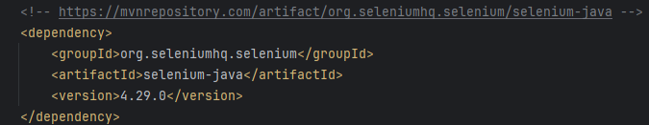

1. Create a class in main folder

